**Portfolio (Week-5)**

This week’s lab session focused on creating a **React application**. React, an open-source JavaScript library, simplifies the process of building user interfaces and is especially useful for creating single-page applications. Below is a detailed explanation of the tasks I performed and the lessons I learned:

1. **Checking Node.js Installation**

Before starting, I verified the installation of Node.js on my computer by running the following command in the terminal:

This command confirmed the installed version of Node.js, ensuring the environment was set up correctly.

• **Setting Up the React Application**

I created a directory named **React Work** in my Week 5 folder and initialized a new React application using the npx command:

After the application was created, I navigated into the myapp directory using the cd command:

Finally, I started the React development server with the command:

**Output**

The default React application loaded successfully in the browser, displaying a sample interface with the React logo.

**Task 1: Modifying the Application Text**

I made changes to the default React application by updating the text displayed on the webpage. Here’s what I did:

* Edited the App.js file to modify the JSX code.
* Changed the heading text to something personalized, such as "Welcome to My React App!".

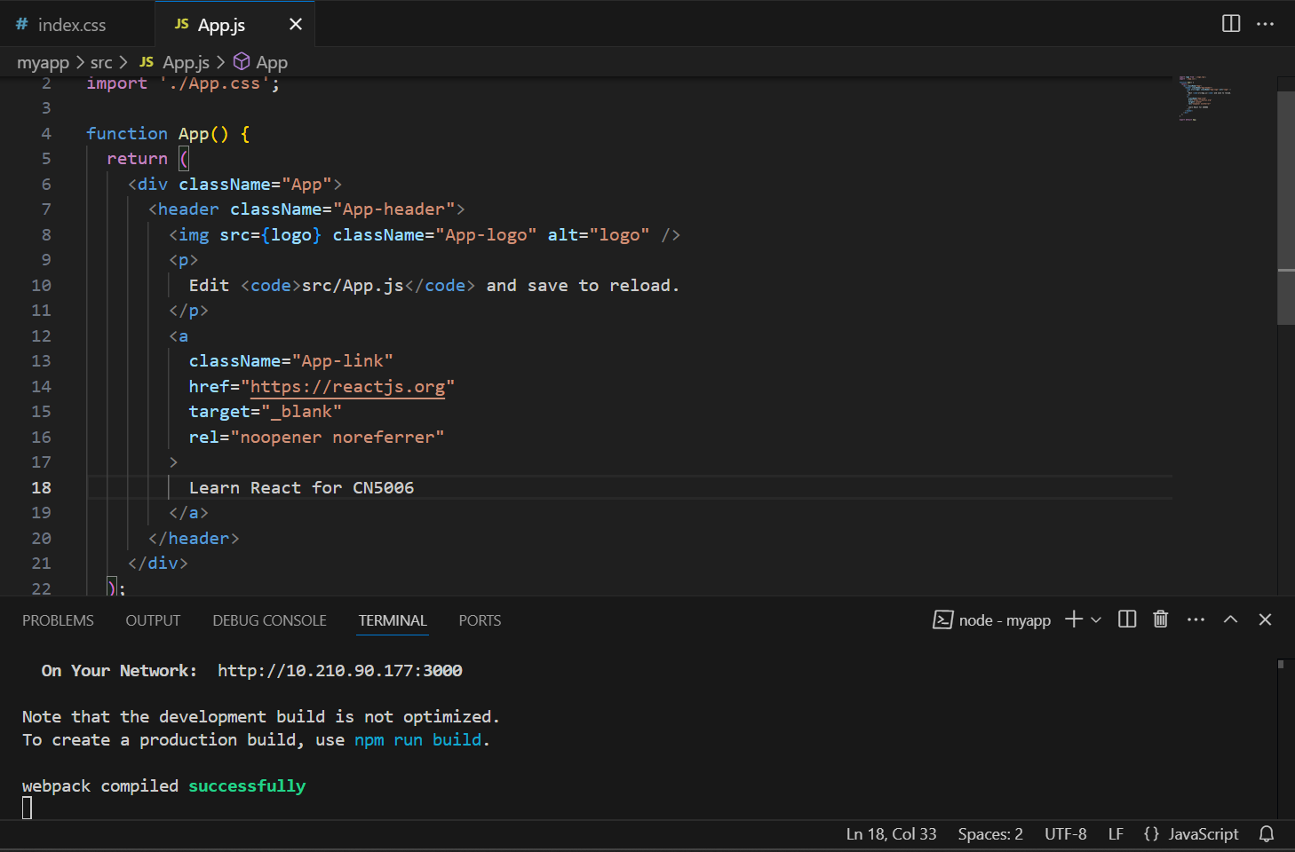

**Output**

The updated text appeared on the webpage as expected.

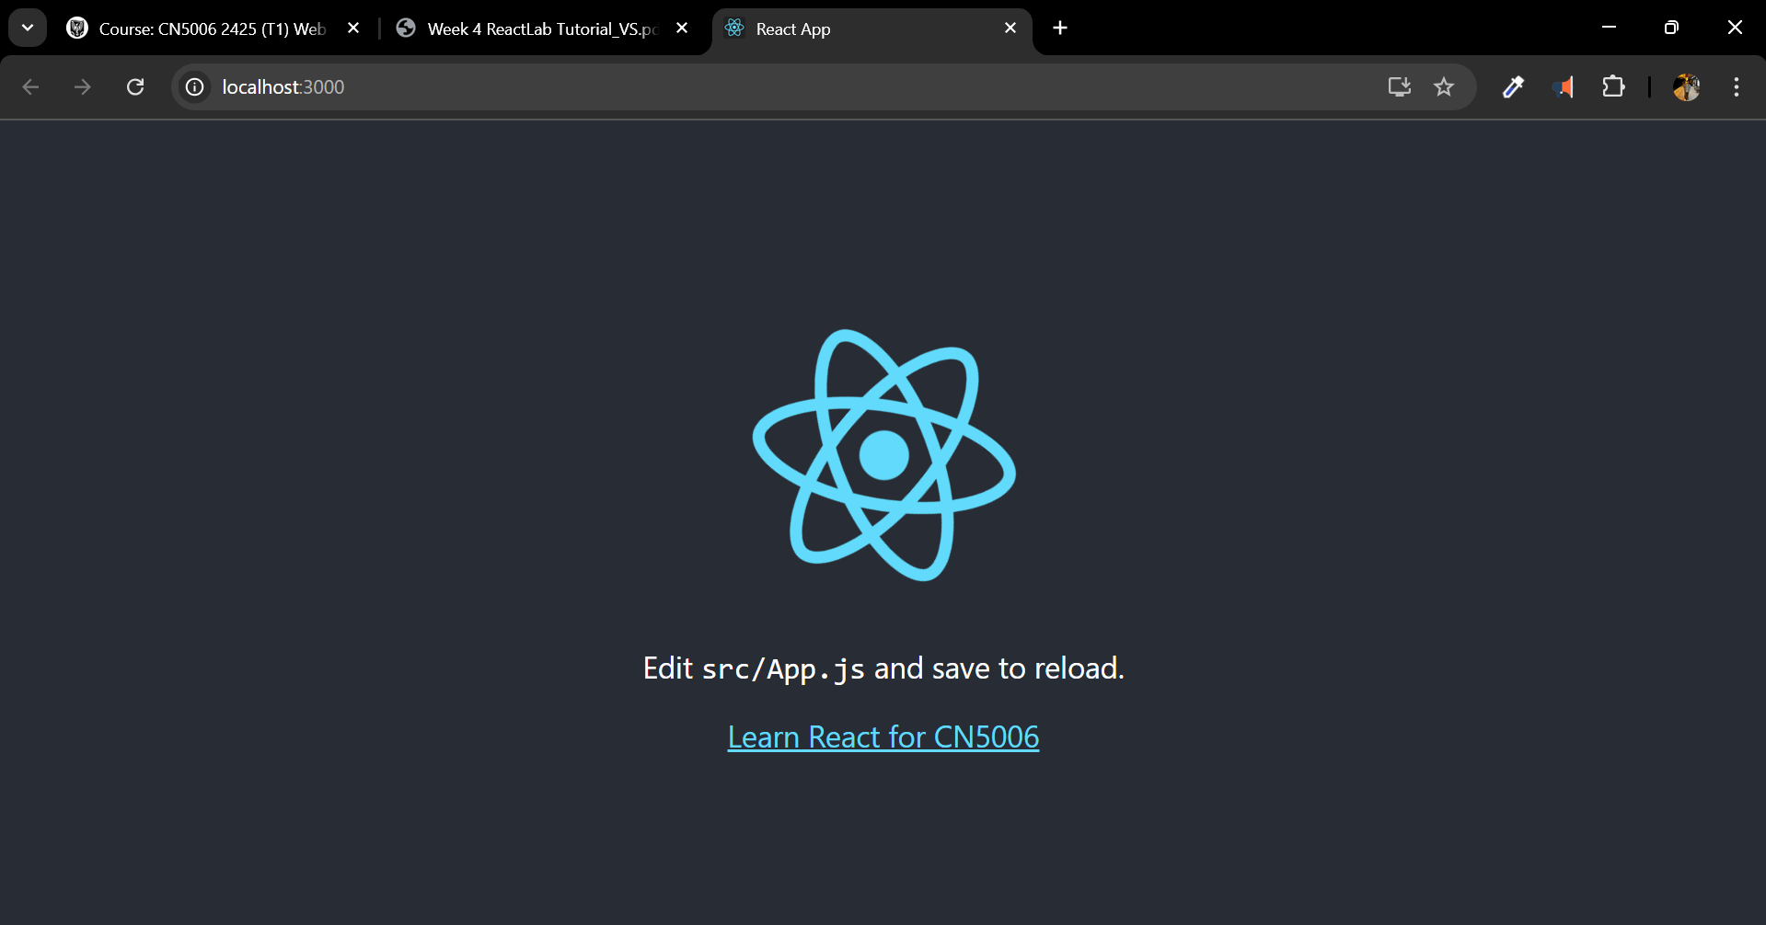

**Task 2: Changing Background Color**

To customize the application further, I changed the background color by editing the App.css file. I replaced the existing color code with a new one to achieve the desired appearance.

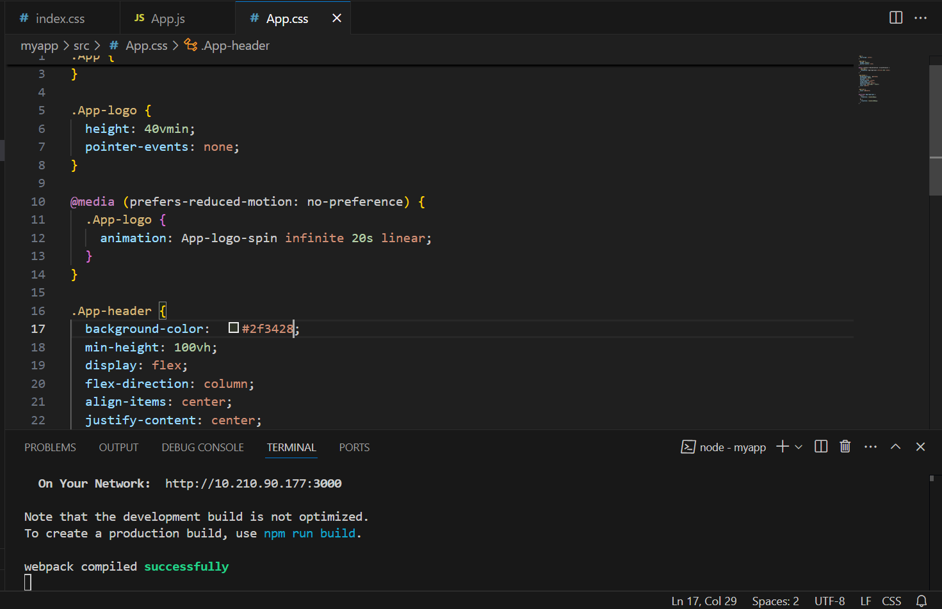

**Output**

The background color of the application changed as specified.

**Task 3: Creating a New React Component**

For this task, I created a new React component called MyGreetingApp. Here’s how I approached it:

1. Created a file named MyGreetingApp.js in the src folder.
2. Wrote a functional component that displays a personalized greeting message.
3. Imported the component into the index.js file.
4. Replaced the <App /> tag in index.js with <MyGreetingApp />.

**SS**

**Output**

The browser displayed the greeting message from the MyGreetingApp component.

**Task 4: Working with Props**

In this task, I created another component named MyGreetingProp.js, which demonstrates the use of props. Here are the steps:

1. Created the MyGreetingProp.js file in the src folder.
2. Defined a functional component that accepts a name prop and displays a greeting message.
3. Imported and used the component in index.js, passing a name value as a prop.

**Output**

The browser displayed a personalized greeting message based on the passed prop.

**Task 5: Creating Weekly Greetings**

To create greetings for each day of the week, I followed these steps:

1. Copied the greeting line for Monday and updated it for other days of the week.
2. Ensured that all days were displayed dynamically in the application.

**Output**

The browser displayed greetings for all seven days of the week.

**Task 6: Changing Background Color Dynamically**

For this task, I created a file named AppBackgroundColour.js. Here’s what I did:

1. Defined a component that dynamically changes the background color based on user interaction or predefined logic.
2. Imported this component into index.js and incorporated it into the application.

Now let’s jump on to the question and answer part:

1. What is React

Ans: React is open-source JavaScript library that is created by Facebook. It helps in building user interfaces, and it is especially used for single-page applications.

1. What do you understand by React component and what command do you use to create a React component with or without property

Ans: React component is reusable data that defines a part of user interface. When creating React component for with property we use “**function** MyComponent() { **return** Hello, World!; }” and for without property we use “**function** MyComponent(props) { **return** <h1>Hello, {props.name}</h1>; }”.

1. What command will you use to render the the newly created component named as MyReact?

Ans: ReactDOM.render(<MyReact />, document.getElementById('root'));

4. Suppose the MyReact Component has a property heading, write down the code that could be used to render the MYReact Component, and pass the message to the property heading as “this is my first element”

Ans: ReactDOM.render( <MyReact heading="this is my first element" />, document.getElementById('root') );

5. Observe this code and answer the questions below

6. <AppColor heading="This is first element" lbl ="Name :" color="green"/>

a. What is the name of the React Component

b. How many properties this component uses

Ans:

a) AppColor

b) Three: heading, lbl, and color

7. Look at the following Code: function GreetingElementwithProp(props) { return (

**Wellcome , {props.studentname}**

;

); } export default ??????

what will you write to make this export this function correctly? Hint you need to replace ?????? with the correct word.

Add a function that takes two properties as numbers ,add these numbers on the click event of the button and display the sum. Hint you will be using in jsx

Ans: To export default: **export** **default** GreetingElementwithProp;

To a function that takes two properties as numbers:

**function** AddNumbers(props) { **const** [sum, setSum] = React.useState(0);

**function** handleClick() { setSum(props.num1 + props.num2); }

**return** ( <div> <button onClick={handleClick}>Add Numbers</button> <p>Sum: {sum}</p> </div> ); }

To add these numbers on the click event of the button and display the sum:

<AddNumbers num1={5} num2={3} />

**Learning Objectives**

* To understand the fundamentals of React and its component-based architecture.
* To practice creating and styling React components.
* To learn how to use props to make components dynamic and reusable.
* To explore the basics of state management in React.

**Key Points**

* React simplifies UI development through reusable components.
* Props allow components to accept dynamic data.
* CSS can be integrated with React to customize the application’s appearance.
* State management enables components to handle dynamic behavior and data updates.

**Problems Faced**

1. **Issue Starting React App:** I encountered an error when running npm start due to a missing dependency.
   * **Solution:** I reinstalled the dependencies using npm install and resolved the issue.
2. **CSS Styling Confusion:** I initially struggled to apply CSS styles to components.
   * **Solution:** I referred to the React documentation and learned how to import and use CSS files correctly.
3. **Prop Usage Errors:** While working with props, I faced errors due to missing or incorrectly defined properties.
   * **Solution:** I ensured that all required props were passed and that the component definitions matched the expected inputs.

By addressing these challenges, I developed a deeper understanding of React and its powerful features for building interactive user interfaces.